Supplementary Information
Breathable, Hygroscopic and Protective Leather-based Wearable Electronic with Stress-humidity Dual-modal Sensing by Janus-structured Porous Design
Xinyi Wangª, Shuai Liuª, Yunqi Xuª, Ziyang Fanª, Zimu Liª, Chunyu Zhao ª, Wei Yang^{b ,*}, Jianpeng Wuª, Shuyu Laiª, Xinglong Gong^{a,c,*}, Shouhu Xuan^{a,c,d*}

a CAS Key Laboratory of Mechanical Behavior and Design of Materials, Department of Modern Mechanics, University of Science and Technology of China, Hefei, Anhui, 230027, P. R. China
b Anhui Provincial Key Laboratory of Urban Rail Transit Safety and Emergency Management, Hefei University, Hefei, Anhui 230601, P. R. China
c State Key Laboratory of Fire Science, University of Science and Technology of China, Hefei 230026, Anhui, P. R. China
d Anhui Provincial Key Laboratory of Aerosol Analysis, Regulation and Biological Effect, Hefei 230031, Anhui, P. R. China

E-mail: yangwei@hfuu.edu.cn
E-mail: gongxl@ustc.edu.cn
E-mail: xuansh@ustc.edu.cn

Supplementary Notes
Note S1 Simulation of anti-gravity water absorption
Simulation of anti-gravity water absorption in aerogels was conducted using COMSOL Multiphysics 6.0 with the “Level Set-Two-Phase Flow” module. First, a two-dimensional model was established by converting the SEM cross-sectional image of the aerogel into a geometric model using the “image_to_curve” plugin. Subsequently, gravity was added in the “Laminar Flow” field, with the lowermost boundary of the geometric model set as a water inlet and the uppermost boundary as a water outlet. In the “Level Set” module, the “air domain” and “water domain” were defined, and the “wetting wall” contact angle was configured as 0 rad. Finally, the simulation calculated key parameters including the volume fraction of the water phase, velocity distribution, and pressure field data.
Note S2 Humidity bottle configuration
The construction of the humidity environment was carried out by adopting the saturated salt solution method reported in the literature[1,2]. The specific operation is as follows: potassium carbonate (K₂CO₃), sodium bromide (NaBr), sodium chloride (NaCl), potassium chloride (KCl), and polyethylene glycol (PEG) were mixed with 50 mL of deionized water and placed together in a 250 mL sealed humidity bottle. Through solid-liquid equilibrium, a saturated vapor environment was formed. To verify the actual humidity parameters, a hygrometer (AS847, SMART SENSOR™) was used to conduct calibration measurements of the relative humidity of the gas phase in the static-sealed system. After correction with the measured data, five gradient humidity environments of 41.6%, 50.0%, 60.3%, 68.8%, and 80.2% were obtained. The accuracy was controlled within ±1.5%RH, which was more in line with the actual situation of this experimental system compared to the values in traditional literature.
Note S3 Simulation of bending sensing
Simulation of LMAA’s bending sensing was conducted using COMSOL Multiphysics 6.3. Utilizing the “Solid Mechanics” and “Current” interfaces, set the “Fixed Constraint”, “Fixed Displacement”, and “Contact” boundary conditions in the “Solid Mechanics” interface, and set the “Electrical Contact Pair”, “Electrical Insulation”, “Continuity”, “Terminal”, and “Grounding” boundary conditions in the “Current” interface. The results will calculate “Displacement”, “Contact Stress”, and “Resistance”.
Note S4 EMI shielding calculation formula
EMI shielding efficiency (EMI SE), R (reflection), and A (absorption) coefficients are calculated according to following equations[3]:
$R={\left|S_{11}\right|}^{2}$ (1)
$A=1-{\left|S_{11}\right|}^{2}-{\left|S_{21}\right|}^{2}$ (2)
$SE_{R}=-10\lg\left(1-{\left|S_{11}\right|}^{2}\right)$ (3)
${SE}_{A}=-10\lg\left(\frac{{\left|S_{21}\right|}^{2}}{1-{\left|S_{11}\right|}^{2}}\right)$ (4)
$EMI SE={SE}_{A}+{SE}_{R}$ (5)

Supplementary Figures

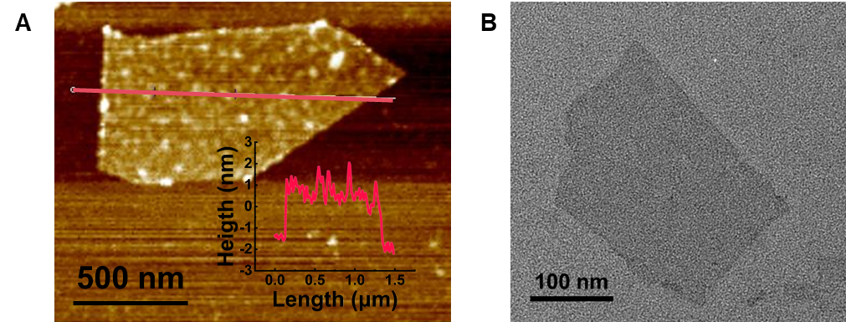
Figure S1 (A) AFM image of MXene nanosheet. The inset image shows the thickness of the MXene nanosheet. (B) TEM image of MXene nanosheet.

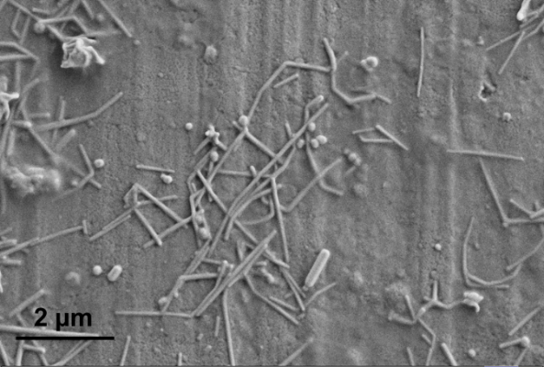
Figure S2 SEM image of AgNWs.

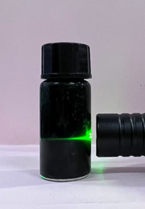
Figure S3 The optical image of the Tyndall effect exhibited by the MXene aqueous solution.

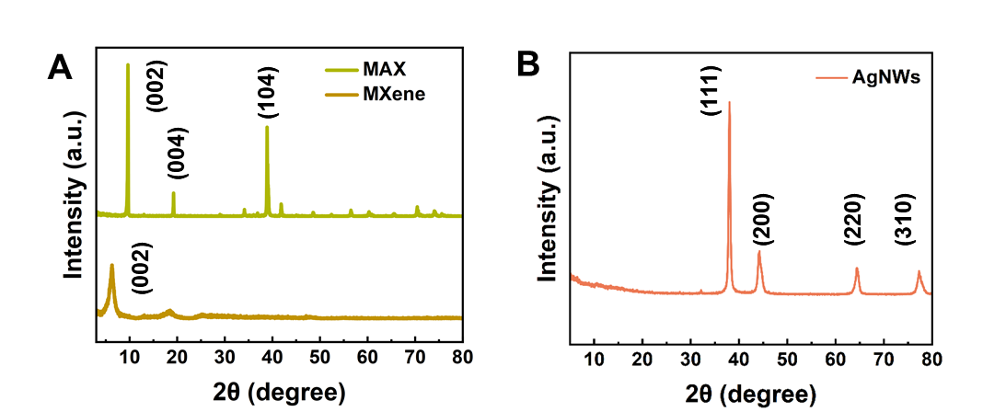
Figure S4 XRD patterns of (A) MXene, MAX, and (B) AgNWs.

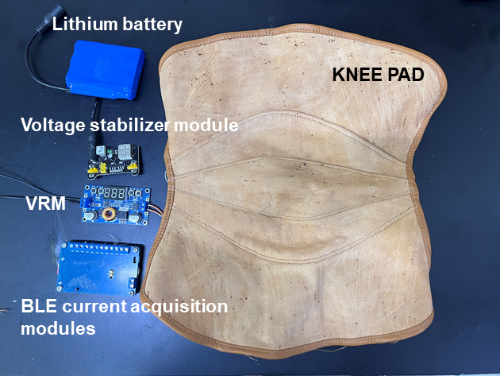
Figure S5 Optical image of the connection diagram of the Bluetooth transmission acquisition module.

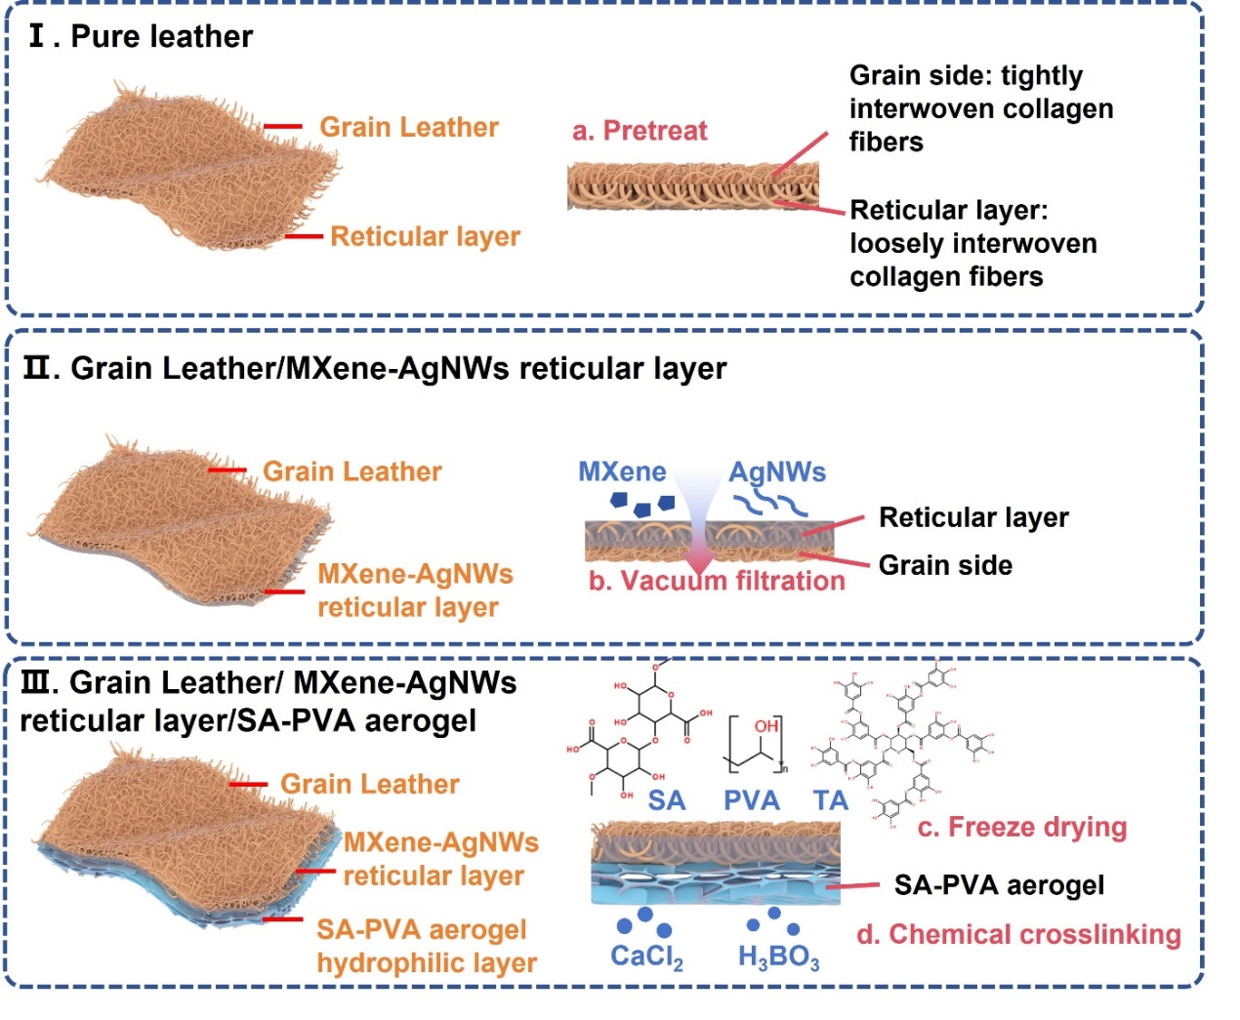
Figure S6 Schematic diagram of LMAA production process.

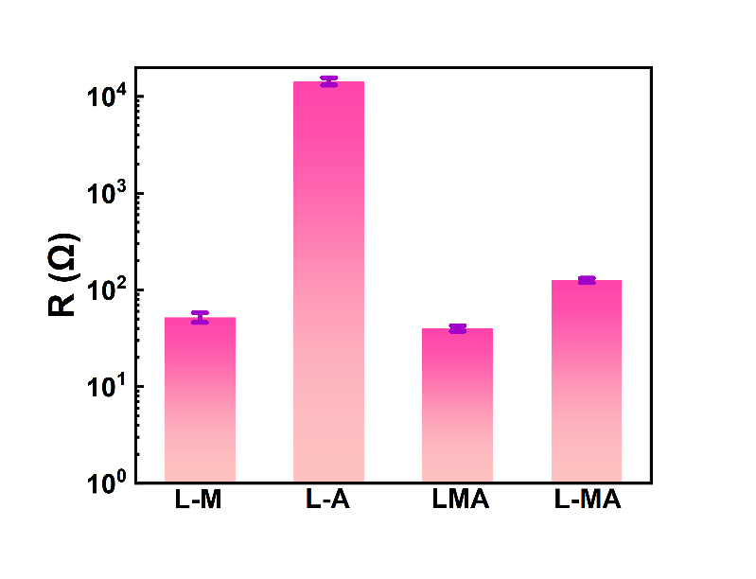
Figure S7 The resistance of the vacuum-filtered 16 mg MXene (L-M), 16 mg AgNWs (L-A), mixed aqueous solutions of MXene-AgNWs (L-MA), and alternately filtered MXene/AgNWs (LMA) onto leather.

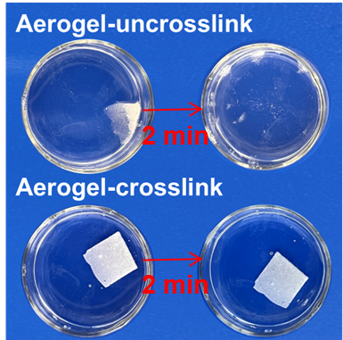
Figure S8 Optical images of the degradation performance of the aerogels without chemical crosslinked and with chemical crosslinked in water.

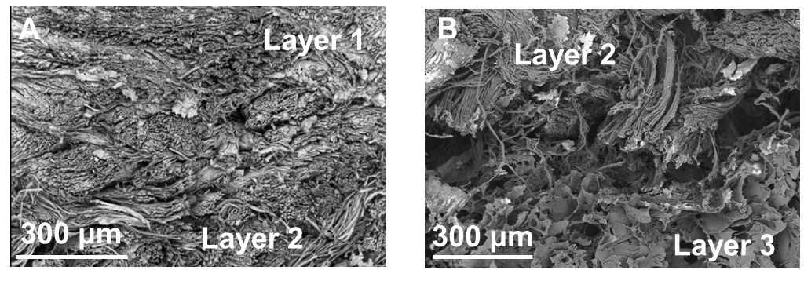
Figure S9 (A, B) SEM images of the cross section of LMAA.

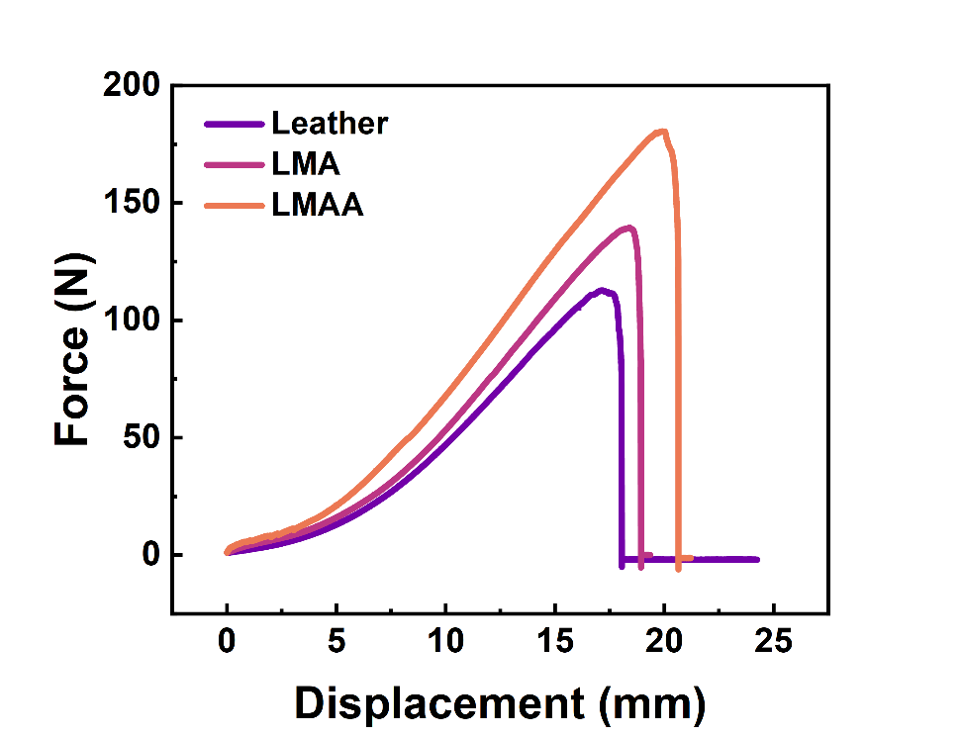
Figure S10 The Force-Displacement curves of tensile testing.

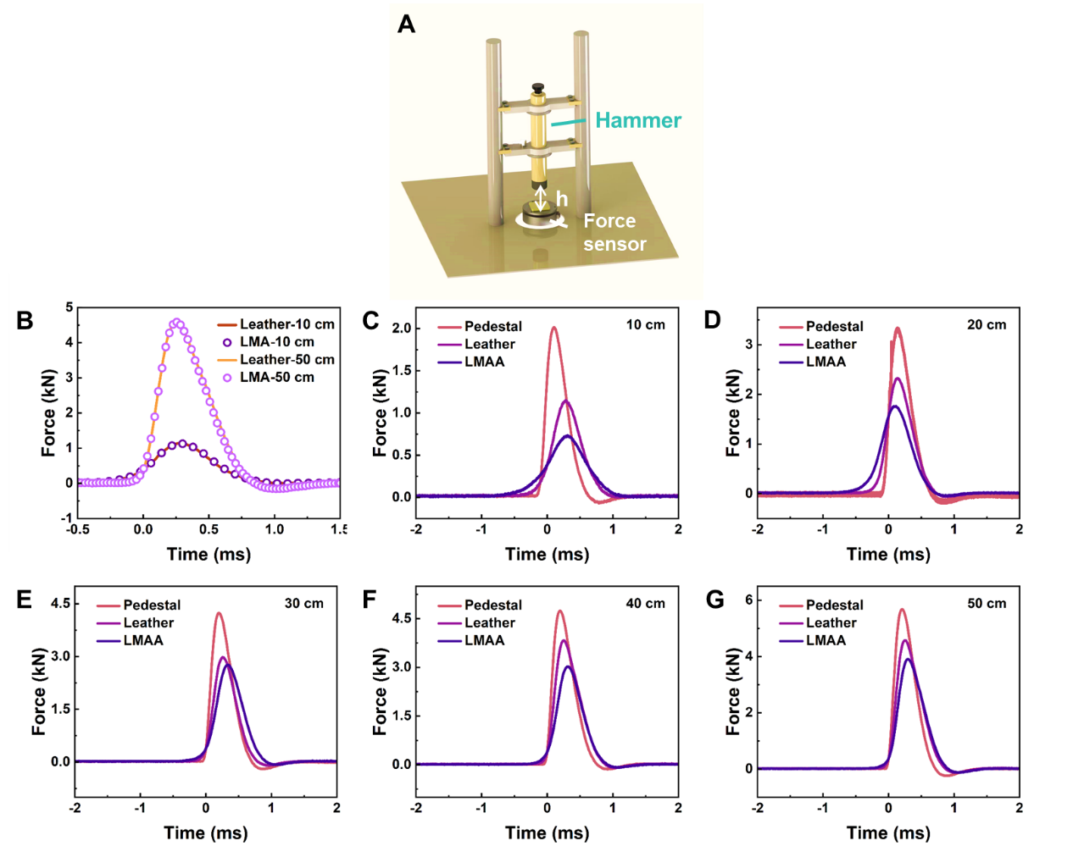
Figure S11 (A) Diagram of the drop hammer device. (B) Force vs time curves for Leather and LMA under 10 cm and 50 cm heights. Force vs time curves for various samples from different heights of (C) 10 cm; (D) 20 cm; (E) 30 cm; (F) 40 cm and (G) 50 cm.

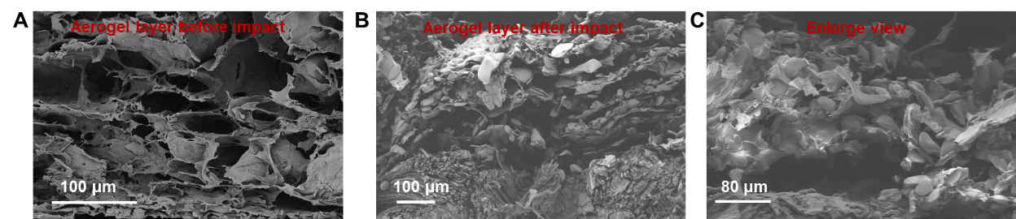
Figure S12 SEM images of the aerogel layer (A) before and (B, C) after drop hammer impact.

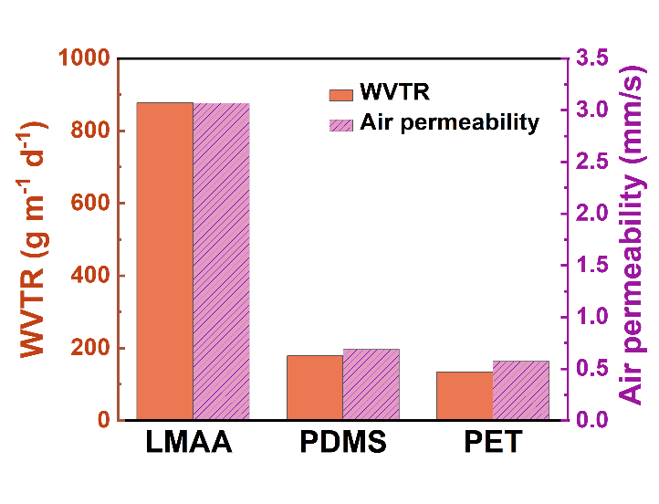
Figure S13 Air permeability and WVTR of PDMS and PET film.

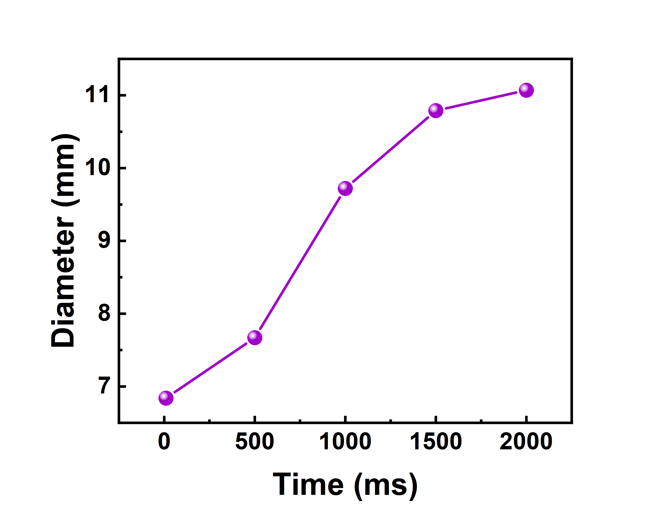
Figure S14 The diameter of the diffusion of water droplets on the surface of aerogel.

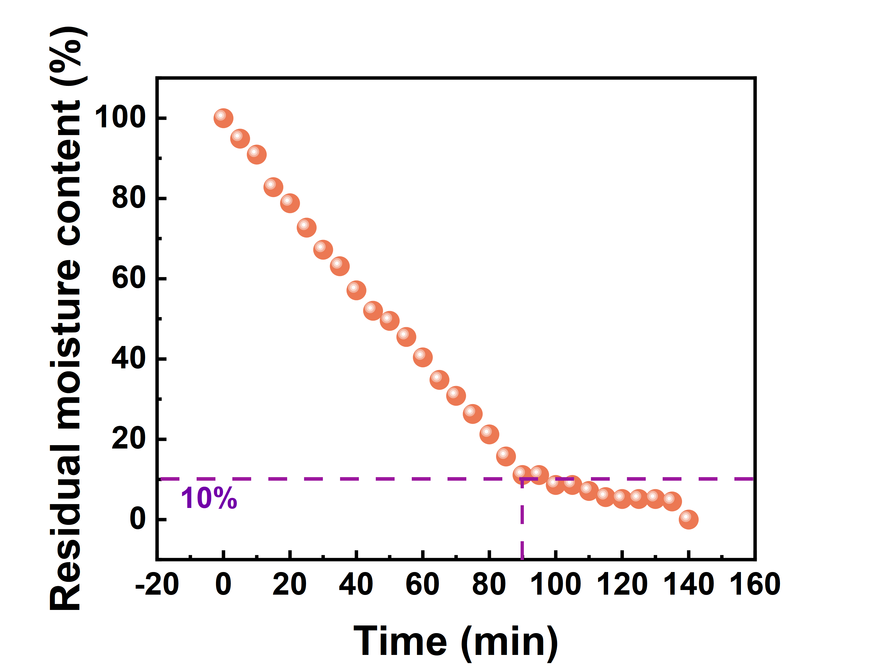
Figure S15 The variation of residual moisture content in LMAA overtime during the evaporation rate test.

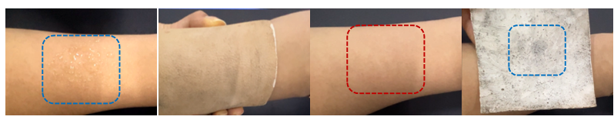
Figure S16 Optical image of LMAA absorbing sweat.

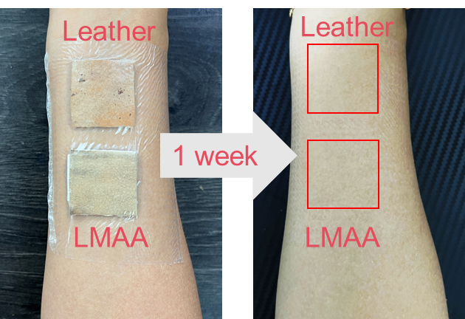
Figure S17 Digital images showing the skin irritation results of Leather and LMAA on the forearms of the volunteer.

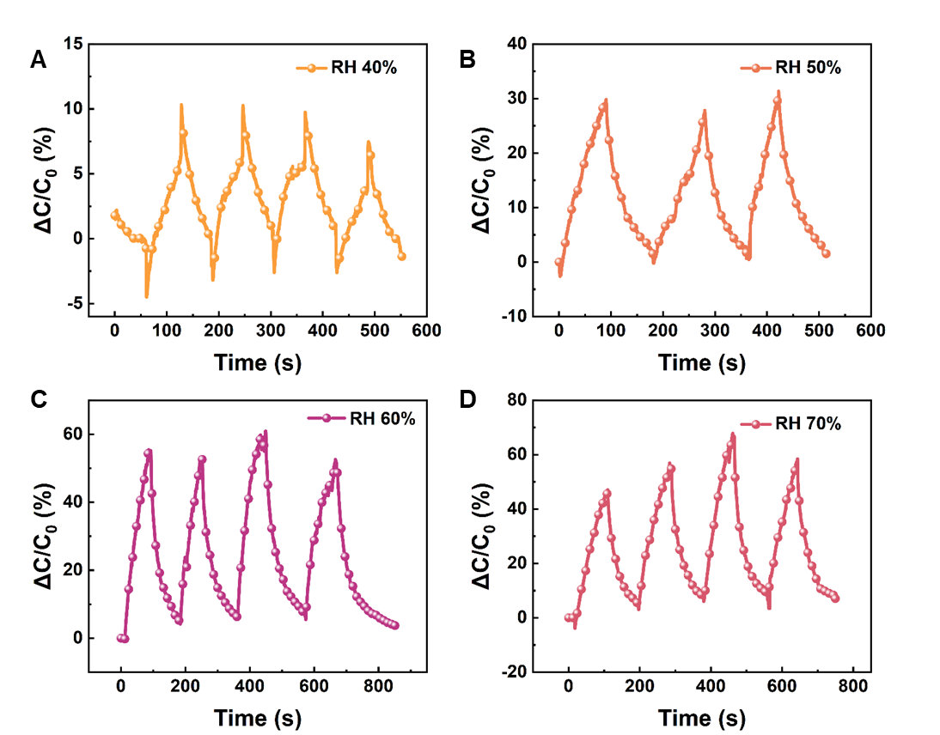
Figure S18 Relative capacitance changes of LMAA when the environment humidity changes from 30% RH to (A) 40% RH, (B) 50% RH, (C) 60% RH, and (D) 70% RH.

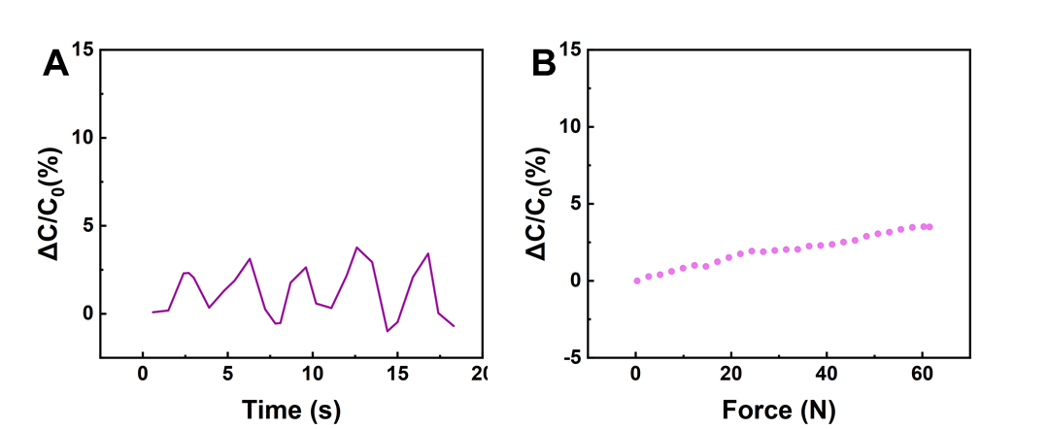
Figure S19 The change in capacitance of LMAA at (A) the maximum bending angle and (B) 40 N compressing force.

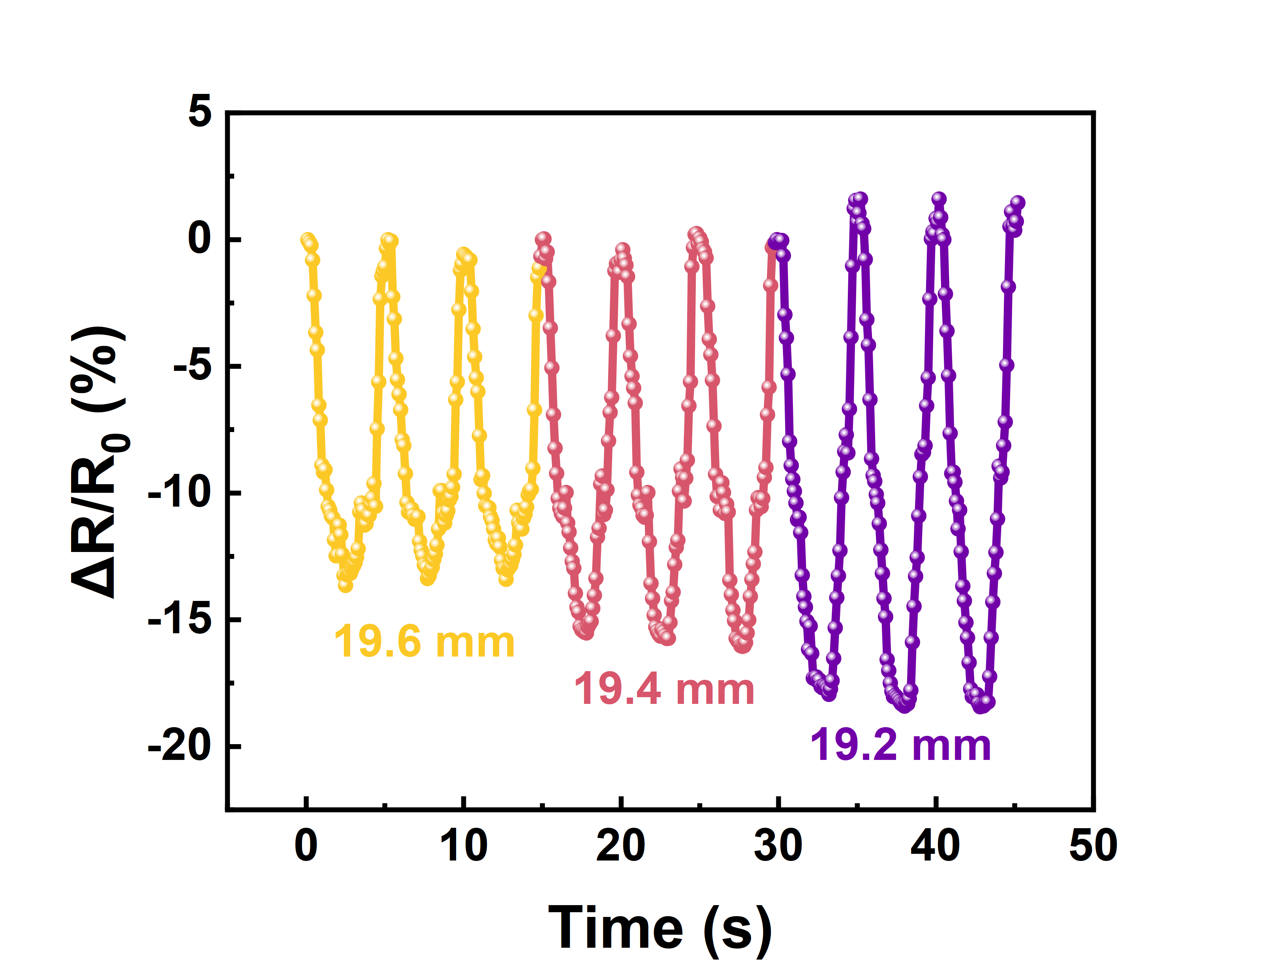
Figure S20 Relative resistance changes of the sensor under bend-release cycles at a maximum chord length of 19.6 mm, 19.4 mm, and 19.2 mm, respectively.

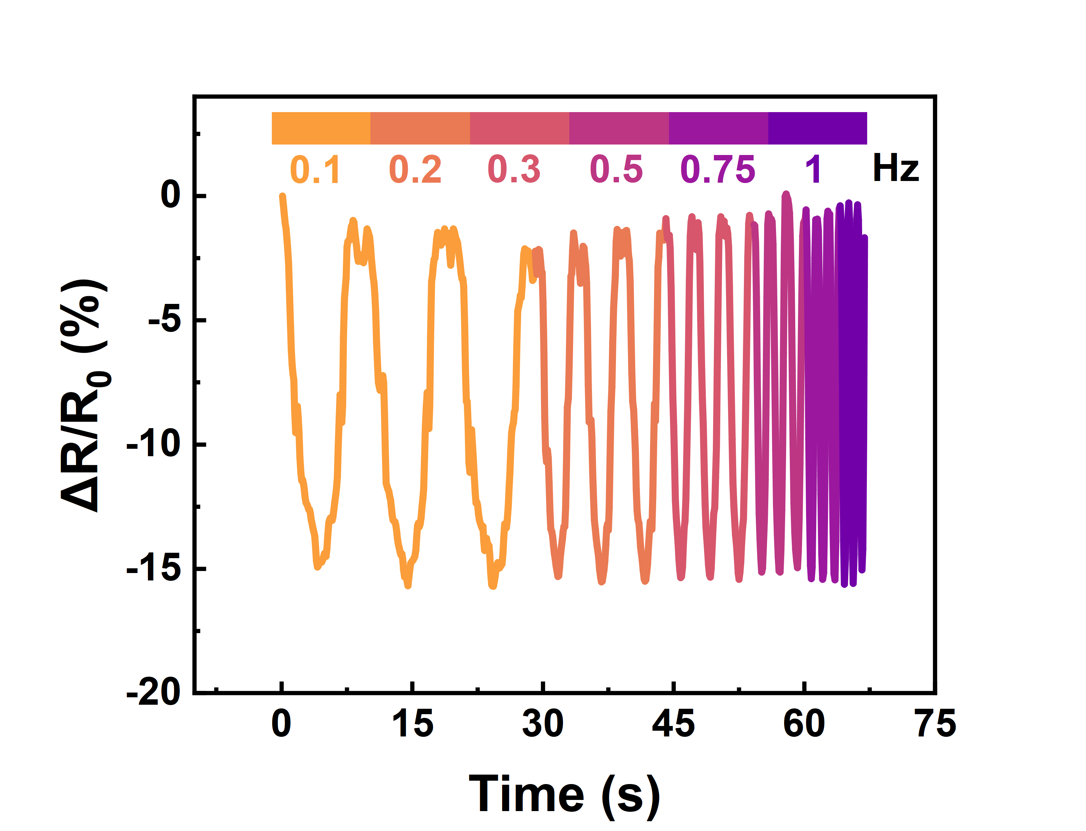
Figure S21 Detection with different frequencies of 0.1-1 Hz under 19.4 mm chord length bending.

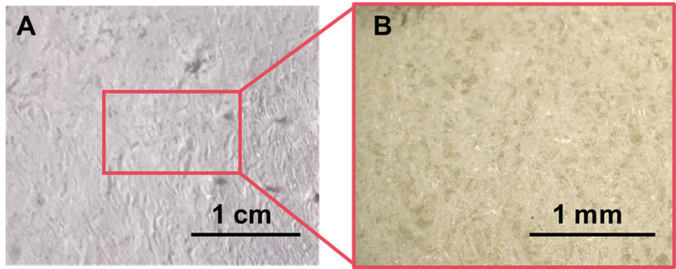
Figure S22 (A, B) Optical image of aerogel’s surface after 10000 bending-release cycles.

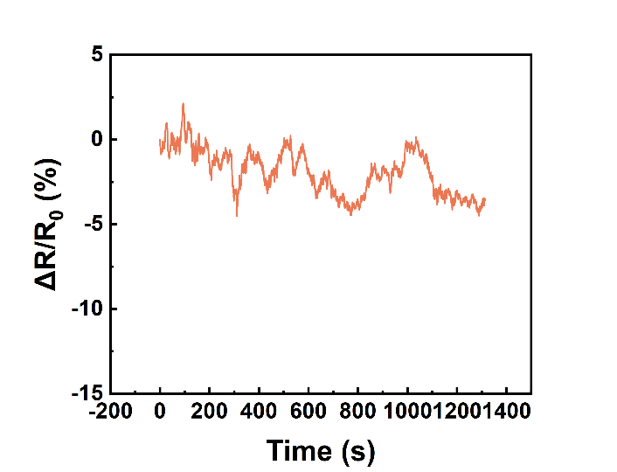
Figure S23 The resistance change rate of LMAA when placed in a sealed environment with a humidity level of over 90% RH created by a humidifier for 20 minutes.

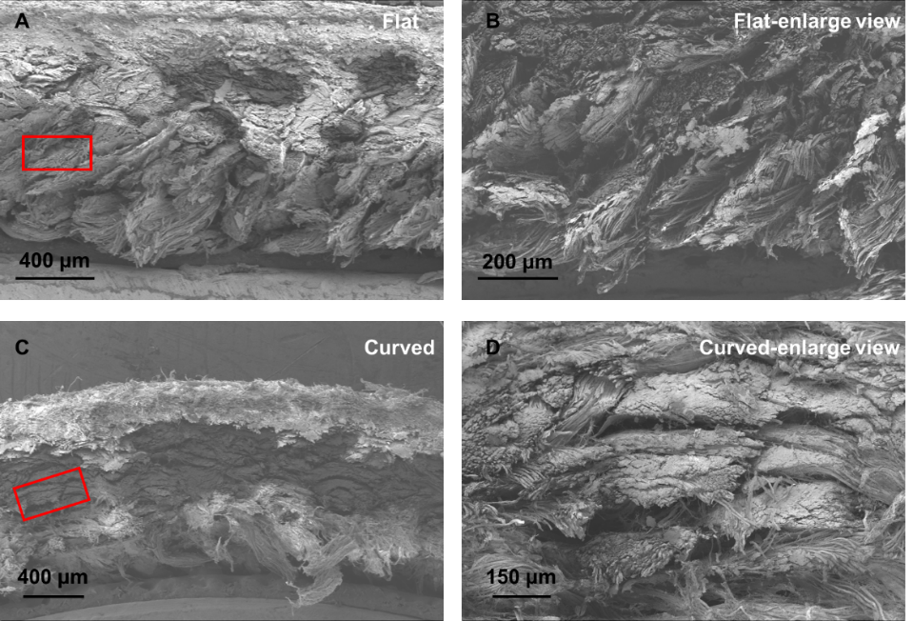
Figure S24 SEM images of (A, B) flat LMA and (C, D) curved LMA in cross-section.

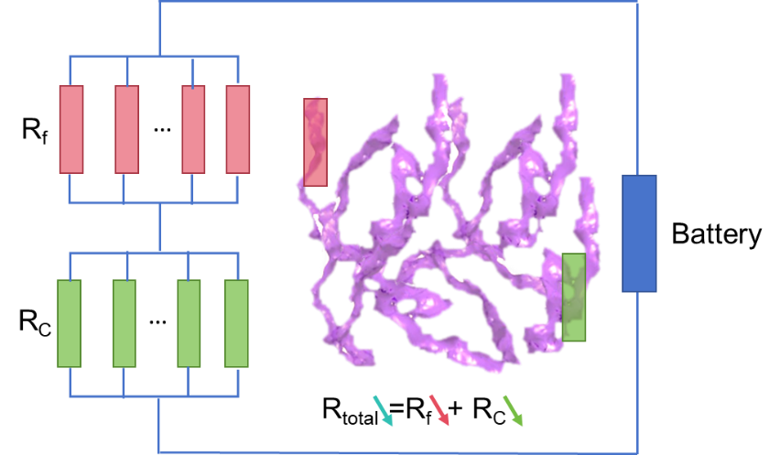
Figure S25 A schematic diagram of contact resistance and resistance of conductive fibers.

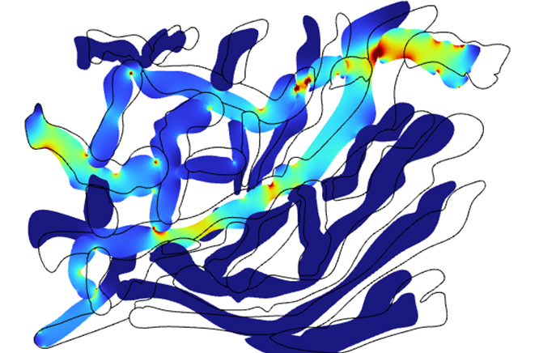
Figure S26 The current density simulation of one unit for fiber interlacing when leather is bent by 0.015 mm.

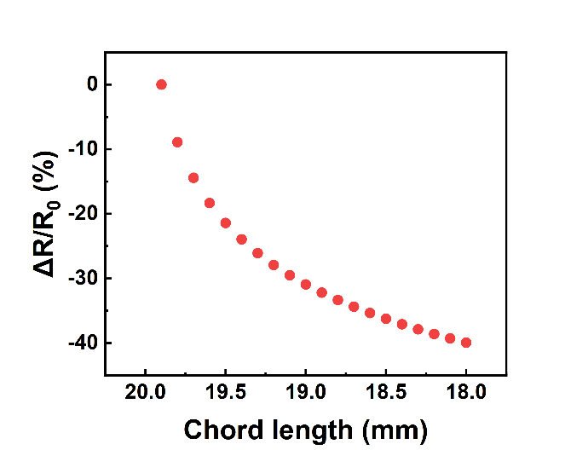
Figure S27 Simulation result of the corresponding relationship between chord length and resistance change rate.

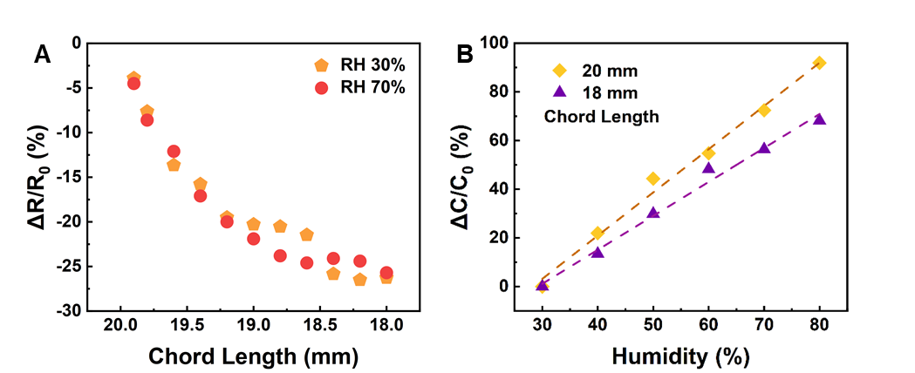
Figure S28 (A) The bending sensing performance of LMAA under high humidity conditions. (B) The humidity sensing performance of LMAA under bending conditions.

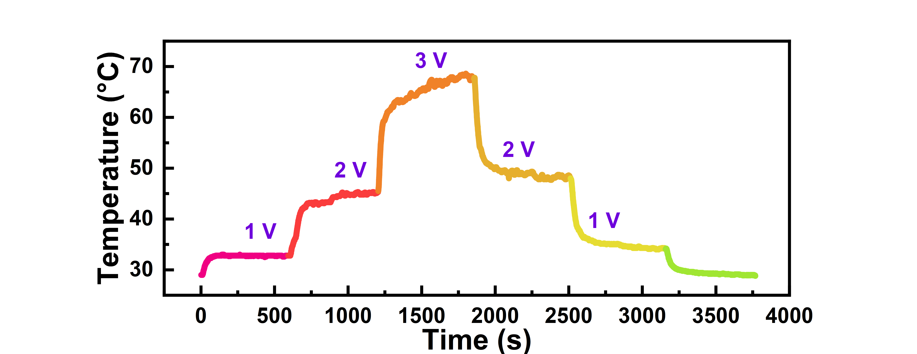
Figure S29 Time-dependent surface temperatures of the LMAA under different voltages.

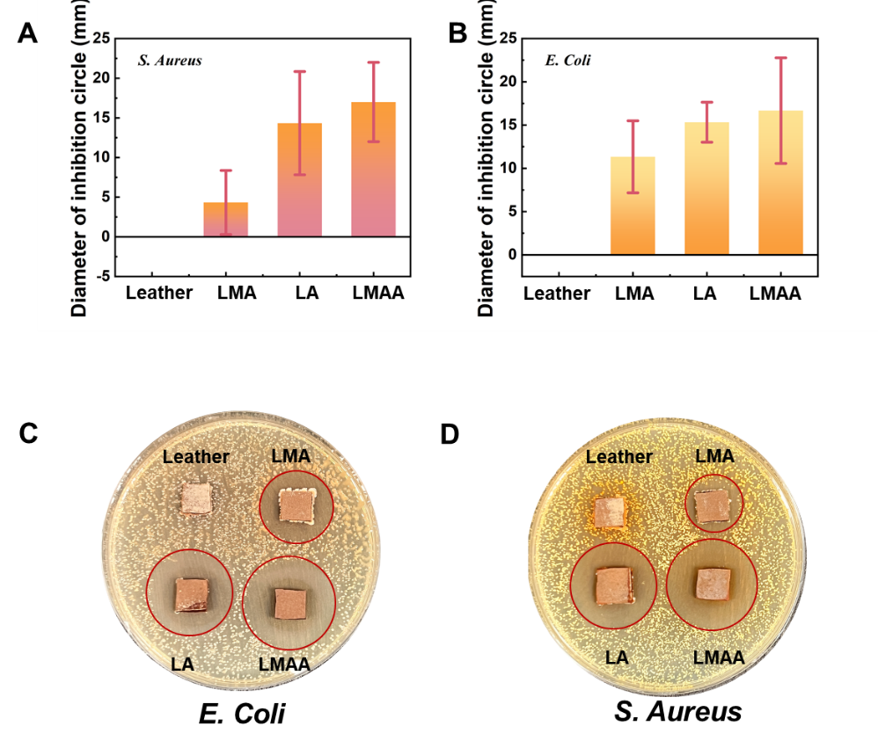
Figure S30 (A) The diameter of the inhibition circle and (C) optical image of the samples against S. Aureus for 14 days. (B) The diameter of the inhibition circle and (D) optical image of the samples against Escherichia coli for 14 days.

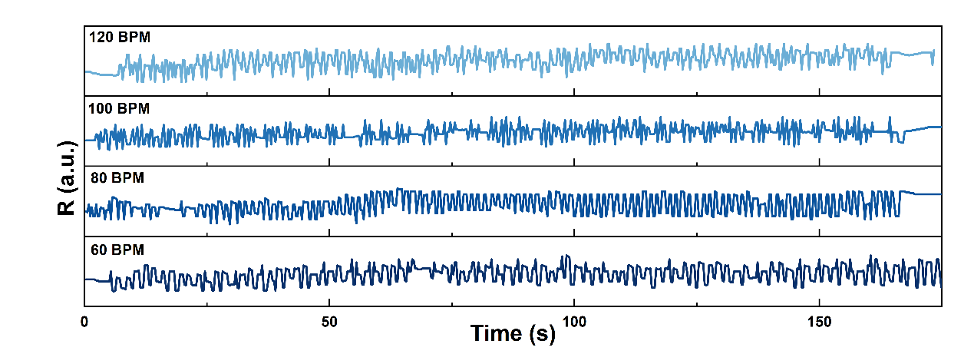
Figure S31 The bending-sensing knee pads monitor the running of volunteers at different beat per minute (BPM).

Supplementary Videos

Video S1 Simulation of anti-gravity water absorption of aerogel.
Video S2 Simulation of stress changes of bending sensors.
Video S3 Simulation of current density modulus change of bending sensors.
Video S4 The BLE bending-sensing knee pads monitor the running of volunteer.

Supplementary Tables
Table S1 Performance comparison of different humidity sensors.
No. | Materials | Detect range (%RH) | Mechanism | Sensitivity  (%/%RH) | Linearity (R²) | Cycles | Ref.
1 | MXene | 0-70 | Resistance | 0.786 | >0.99 | 9 | [4]
2 | CNF-PVA-Ag | 44-83 | Resistance | 0.4 | 0.951 | 14 | [5]
3 | PDMS-CaCl₂ | 30–95 | Capacitance | 3.13 | 0.94 | - | [6]
4 | Poly-MMA/MAPTAC | 20–90 | Impedance | 0.67 | 0.949 | - | [7]
5 | PEDOT-SA-CNF | 20-90 | Resistance | 0.357 | 0.95 | - | [8]
6 | rGO/ MoS₂ | 11-97 | Resistance | 0.49 | 0.98 | 3 | [9]
This work | PVA-SA-CaCl₂-TA-B(HO)₃ | 30-80 | Capacitance | 1.4 | 0.997 | 7

Table S2 Performance comparison of different bending sensors.
No. | Materials | Detect range  (Chord length mm) | Mechanism | Sensitivity | Cycle | Ref.
1 | PDMS-AgNWs | 40-38.5 | Resistance | 16%/1.5 mm | 10000 | [10]
2 | AgNWs-Flax | 20-18 | Resistance | 6%/2 mm | 1000 | [11]
3 | CNF/AgNWs | 40-30 | Resistance | 8%/10 mm | 500 | [12]
4 | Graphene aerogels | 30-0 | Resistance | 26%/30 mm | 10000 | [13]
5 | AgNWs/CB-PDMS | 10-8.6 | Resistance | 1.1%/8.6 mm | 3000 | [14]
6 | PDMS/NdFeB/AgNWs | 20-12.5 | Resistance | 9.04%/mm | 4000 | [15]
This work | Leather/ AgNWs-MXene- | 20-18 | Resistance | 26.67%/2 mm | 10000

Table S3 Summary of EMI shielding parameters of six materials.
 | R | A | SE_{A} (dB) | SE_{R} (dB) | SE_{T} (dB)
L-M | 72.60% | 26.78% | 22.97 | 5.78 | 28.63
L-A | 78.29% | 21.00% | 19.71 | 6.85 | 26.05
LMA | 64.07% | 35.42% | 34.19 | 4.61 | 38.31
L-MA | 54.65% | 42.85% | 10.70 | 3.31 | 14.13
Leather | 4.68% | 17.74% | 0.9 | 0.21 | 1.27
Aerogel | 15.55% | 34.7% | 2.34 | 0.74 | 3.64

Reference
[1] T. Li, L. Li, H. Sun, Y. Xu, X. Wang, H. Luo, Z. Liu, T. Zhang, porous ionic membrane based flexible humidity sensor and its multifunctional applications, Adv. Sci. 4 (2017) 1600404.
[2] Y. Liang, Q. Ding, H. Wang, Z. Wu, J. Li, Z. Li, K. Tao, X. Gui, J. Wu, Humidity sensing of stretchable and transparent hydrogel films for wireless respiration monitoring, Nano-Micro. Lett. 14 (2022) 183.
[3] M. Sang, S. Liu, W. Li, S. Wang, J. Li, J. Li, S. Xuan, X. Gong, Flexible polyvinylidene fluoride(PVDF)/MXene(Ti₃C₂T_{x})/Polyimide(PI) wearable electronic for body Monitoring, thermotherapy and electromagnetic interference shielding, Compos. Part A-Appl. S. 153 (2022) 106727.
[4] I. Janica, V. Montes-García, F. Urban, P. Hashemi, A.S. Nia, X. Feng, P. Samorì, A. Ciesielski, Covalently functionalized mxenes for highly sensitive humidity sensors, Small Methods 7 (2023) 2201651.
[5] S. Liu, W. Li, X. Wang, L. Lu, Y. Yao, S. Lai, Y. Xu, J. Yang, Z. Hu, X. Gong, K.C. F. Leung, S. Xuan, Permeable, stretchable, and recyclable cellulose aerogel on-skin electronics for dual-modal sensing and personal healthcare, ACS Nano 19 (2025) 3531–3548.
[6] Y. Komazaki, S. Uemura, Stretchable, printable, and tunable PDMS-CaCl₂ microcomposite for capacitive humidity sensors on textiles, Sensor Actuat. B-Chem. 297 (2019) 126711.
[7] P.-G. Su, C.-F. Chang, Fabrication and electrical and humidity-sensing properties of a flexible and stretchable textile humidity sensor, J. Taiwan Inst. Chem. E. 87 (2018) 36–43.
[8] H. Françon, Z. Wang, A. Marais, K. Mystek, A. Piper, H. Granberg, A. Malti, P. Gatenholm, P.A. Larsson, L. Wagberg, Ambient-Dried, 3D-printable and electrically conducting cellulose nanofiber aerogels by inclusion of functional polymers, Adv. Funct. Mater. 30 (2020) 1909383.
[9] S.Y. Park, J.E. Lee, Y.H. Kim, J.J. Kim, Y. S. Shim, S.Y. Kim, M.H. Lee, H.W. Jang, Room temperature humidity sensors based on rGO/MoS₂ hybrid composites synthesized by hydrothermal method, Sensor Actuat. B-Chem. 258 (2018) 775–782.
[10] Q. Shu, Z. Xu, S. Liu, J. Wu, H. Deng, X. Gong, S. Xuan, Magnetic flexible sensor with tension and bending discriminating detection, Chem. Eng. J. 433 (2022) 134424.
[11] Q. Shu, T. Hu, Z. Xu, J. Zhang, X. Fan, X. Gong, S. Xuan, Non-tensile piezoresistive sensor based on coaxial fiber with magnetoactive shell and conductive flax core, Compos. Part A-Appl. S. 149 (2021) 106548.
[12] R. Yin, S. Yang, Q. Li, S. Zhang, H. Liu, J. Han, C. Liu, C. Shen, Flexible conductive Ag nanowire/cellulose nanofibril hybrid nanopaper for strain and temperature sensing applications, Sci. Bull. 65 (2020) 899–908.
[13] P. Min, X. Li, P. Liu, J. Liu, X. Q. Jia, X. P. Li, Z. Z. Yu, Rational design of soft yet elastic lamellar graphene aerogels via bidirectional freezing for ultrasensitive pressure and bending sensors, Adv. Funct. Mater. 31 (2021) 2103703.
[14] M. Li, S. Chen, B. Fan, B. Wu, X. Guo, Printed flexible strain sensor array for bendable interactive surface, Adv. Funct. Mater. 30 (2020) 2003214.
[15] D. Li, M. Sang, Z. Li, X. Gong, C. Lou, W. Li, J. Wu, Z. Fan, Q. Ma, K.C. F. Leung, H. Ma, S. Xuan, Magnetic flexible sensor with randomly distributed pine-branch microstructure for bidirectional recognition, Compos. Sci. Technol. 254 (2024) 110687.

